Experiment 5.2
Step Response of the System
Expected Learning Outcomes
After completion of this experiment, students will be able to:
1. Define and generate a step input signal to study system behavior under sudden input
changes.
2. Model a discrete-time system using numerator and denominator coefficients of a
difference equation.
3. Compute the step response of a system using MATLAB’s filter() function.
4. Analyze and interpret the input and output response plots to understand system
characteristics and behavior.
Aim:
To analyze the step response of a discrete-time system. The step response characterizes how
the system responds to a step input, which is a common way to assess the transient and
steady-state behavior of the system.
System Definition:

Program:
% Step Response of the System
clc;
clear;
close all;
% Sample index
n = 0:10;
% Unit step input
x = ones(1,length(n));
% System: y(n)=x(n)+0.5x(n-1)
b = [1 0.5];
a = [1];

% Step response
y = filter(b,a,x);
% Display result
disp('Step Response y(n):');
disp(y);
% Plot
figure;
subplot(2,1,1);
stem(n,x,'filled');
grid on;
title('Unit Step Input u(n)');
xlabel('n');
ylabel('Amplitude');
subplot(2,1,2);
stem(n,y,'filled');
grid on;
title('Step Response of the System');
xlabel('n');
ylabel('y(n)');
Output Waveform:
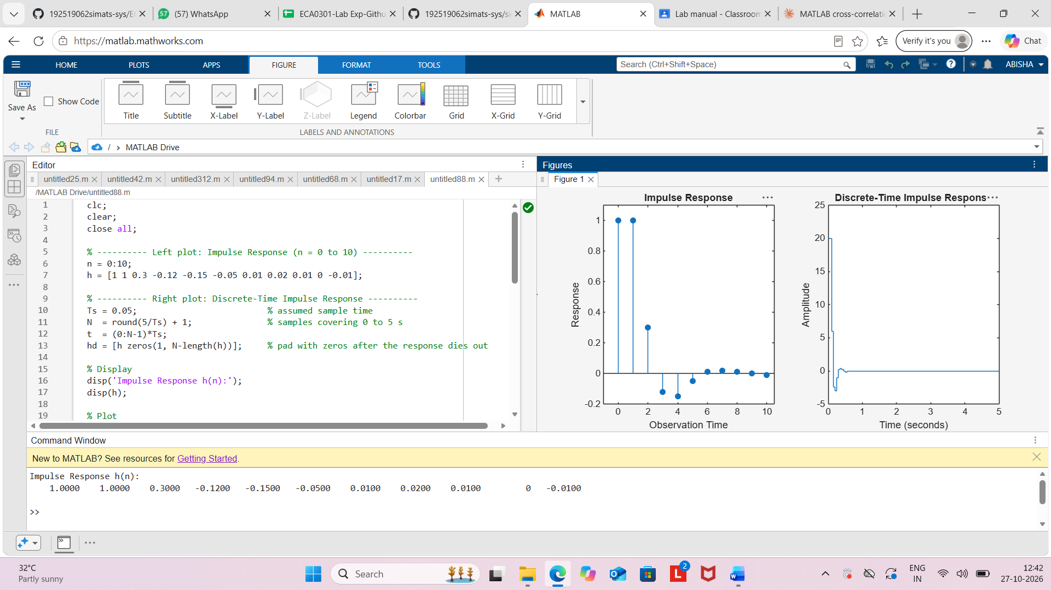

Result:
The step response of the discrete-time system y(n)=x(n)+0.5x(n−1) was obtained by
applying a unit step input. The output reached a steady-state value of 1.5, demonstrating the
response of the system to a constant input signal.

